LIS4708 Perspectives of Information Technology

Fall 2009 Communication Project
Objective: To ready a Cisco switch for network operation.
Purpose: The purpose of this documentation is for the user to follow along with the instructional video. Users will be able to follow the instructor in a step-by-step process to complete the objective.
Instructor:
Bobby Martin - RobertSMartinJr@gmail.com
What you will need to complete the objective:
A computer with a serial port and the ability to run a terminal program.
A Cisco Switch, at least Catalyst 2950
A telnet program. We will be using Hilgraeve’s HyperTerminal for the tutorial.
A console cable (or any cable with an adapter to go from an Ethernet port to DB-9 port, aka Serial port).
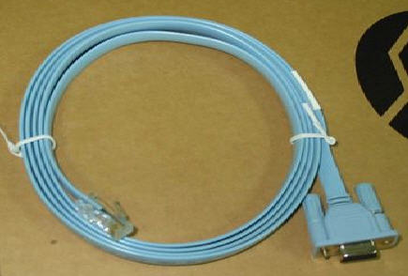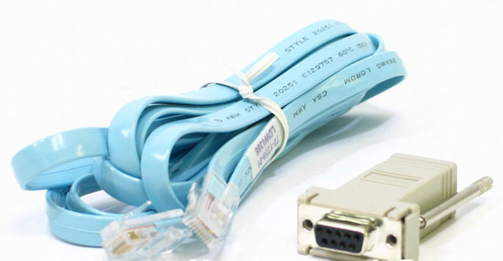
An Ethernet cable, any category.
A serial-to-usb adapter if your computer is too modern to have a serial port.

Step one: Connect the computer and switch physically.
Insert the RJ-45 end of the console cable into the switch and the DB-9 side into your computer’s serial port (or adapter).
Step Two: Configure your terminal client.
Open your terminal program and, choose the COM port that the switch is plugged into and give it a name like “Cisco Switch” or something meaningful if you want to save these settings later on. Then configure it with the following settings (if using HT, just use default settings):
- Bits Per second : 9600
- Data Bits : 8
- Parity : None
- Stop Bits : 1
- Flow Control : None
Without these settings the switch will not recognize any keystrokes that you input.
Step three: Connect the computer to the switch logically.
Turn the switch on. At this point you will see a lot of text start scrolling through your terminal client, this is the switch booting up. If your switch does not have a configuration it will ask if you want to start the configuration wizard. Choose no. You will then be given a prompt like so:
Switch>
Congratulations, you are now able to talk with the switch.
Step four: Configuring the switch.
Note: In the video I will be using a number of “shortcut” commands. These are extremely common in Cisco network peripherals and allow network operators to move around a configuration more swiftly. If you get lost, simply read the commands listed here as they are the “full” commands. For this part of the instruction, bolded lines are commands I will input to the switch and italicized comments with exclamation points are just notes. In a real Cisco config file all comments are preceded by exclamation points, so this is good practice.
Enable the router:
Switch>enable
! Alternatively you can type “en”. You will then be given a prompt that looks like this.
Switch#
! We want to go one step further and get inside the configuration. To do this we type:
Switch#configure terminal
! Or we could just type “conf t” for short. Our prompt is now:
Switch(config)#
! The first thing we want to do is give our switch a meaningful name, or else we’d call all of our switches “Switch”.
! To do so we type:
Switch(config)#hostname HelloSwitch
! Just like “Hello World”. And immediately we see the fruits of our labors. The prompt has changed.
HelloSwitch(config)#
! Next we want to password protect our switch with an encrypted key. Then we’re going to password protect the
! ports on our switch so we can telnet in over TCP/IP instead of consoling in. So first off, since once we’re done
! with our console session we won’t be consoling in again, let’s password protect the console.
HelloSwitch(config)# line console 0
HelloSwitch(config-line)#password keepout
HelloSwitch(config-line)#login
! Now if we consoled in again we would be met with a password prompt. Let’s do the same with our ports. To go
! back to the global config, hit ctrl+Z. This brings us back to the enabled prompt, so first get back in config mode.
HelloSwitch#conf t
HelloSwitch(config)#line vty 0 15
HelloSwitch(config-line)#password keepout
HelloSwitch(config-line)#login
! Now when we set up our IP address on our switch we’ll be able to get in via TCP/IP. Ctrl+Z.
HelloSwitch#
! Now the most important password we can set. The enable password, which we will encrypt. Let’s get to the
! Global config then enter the command.
HelloSwitch#conf t
HelloSwitch(config)# enable secret keepout
! That has set our password to “keepout”. When we type “enable” at “Switch>” we’ll be prompted for this.
! If someone were to somehow steal our config file they would see a big mess of characters in place of that
! password. The last thing we need to do in order to remote in instead of console in is to set up the IP of our vlan.
! We need to get into the vlan interface to do this.
HelloSwitch(config)#interface vlan1
! Our prompt changes to:
HelloSwitch(config-if)#
! We could rename our vlan, but we only have one so we won’t bother. It’s similar to renaming the switch. First
! things first, let’s turn our vlan on. It’s weird, but this is the command to make it so:
HelloSwitch(config-if)#no shutdown
! And that turns it on. Let’s set the IP address.
HelloSwitch(config-if)#ip address 192.168.0.1 255.255.255.248
! Our vlan now has an IP address. Any port that is enabled for vlan access can be used to remote in to the switch.
! So the last thing to do is actually set up one of our ports so it can be used for just that purpose.
! Ctrl+Z, then type the following command to get to the interface for the first Ethernet port on our switch
! after getting back to the global config.
HelloSwitch#conf t
HelloSwitch#interface FastEthernet0/1
! Your prompt will now look like this:
HelloSwitch(config-if)#
! Just the same as it did in the vlan interface. To enable this port, it’s the same command
HelloSwitch(config-if)#no shut
! Then we’ll enable it for vlan access with the following commands:
HelloSwitch(config-if)#switchport mode access
HelloSwitch(config-if)#switchport access vlan1
! We should now be able to remote into our switch.
! We’ll set our computer’s IP, subnet, and gate manually to that they are 192.168.0.2, 255.255.255.248
! and 192.168.0.1 respectively. Once done we use hyperterminal only this time with the following settings.
Choose TCP/IP in “Connect using” prompt this time.
For “Host address” put in 192.168.0.1, or whatever you set your vlan IP to.
And leave Port number as the default, 23.
Hit “OK”.
! As soon as you connect you will be prompted for the password we set earlier, enter it. If correct, you should be
! met with the switch’s main prompt. Type “enable” to enter.
! You will then be met with the prompt to get into the switch. Type in that password and you are now able to
! remotely access your switch on the network. Congratulations.
! From here we will save our configuration. And that’s it. You’re finished.
HelloSwitch>en
HelloSwitch#wr mem
! Some handy commands to know (long command // short command):
Show running-config // show run – shows the running configuration (not saved)
Write memory // wr mem - Saves the current running configuration
Write erase // wr er – erase the non-volatile ram, not the running config. Reboot to lose running.
Reload – reboots the Cisco device
Need to run a command but not at the right prompt? Put the word “do” in front of the command.
Examples:
Do sh run
Do wr mem

